USER DOCUMENTATION

The application is not in the play store as of yet, so to install the application, you need to clone or download the application from the github repo (<https://github.com/ubaada/COSC345-Project>) then copy the APK located at “/app/build/outputs/apk/debug/app-debug.apk” within the repo, copy that to your phone via your computer, then open the APK on your phone after enabling “install from untrusted sources” in your phones settings, alternatively you can build from source within Android studio and deploy the application to your phone.

After installing the application, give the app location permissions (for the distance estimate and nearest outlet selection to work properly) under settings.

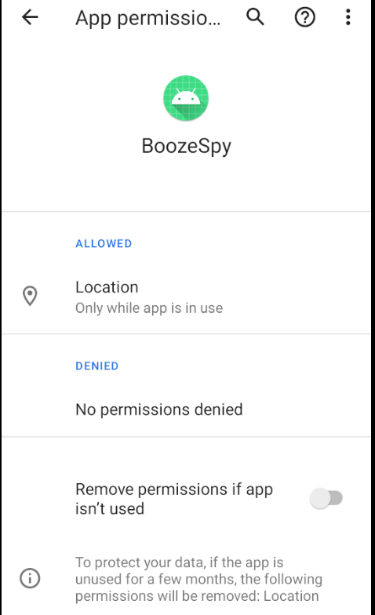

Then open the application, you will be greeted with a screen like this. 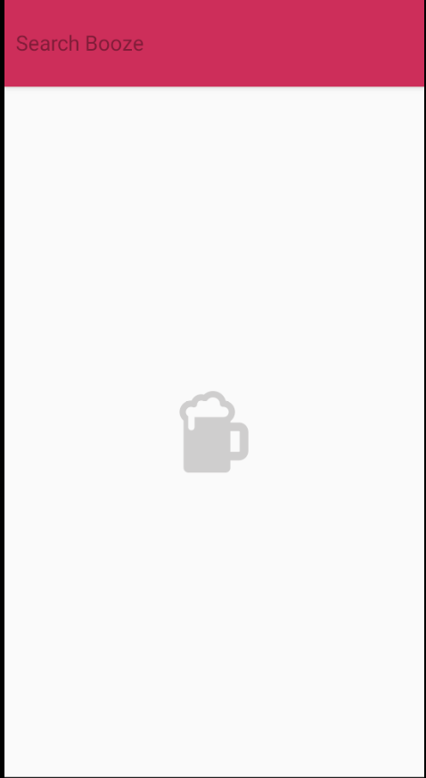

Tap the “Search Booze” field and search what alcoholic beverage you would like to do price comparison on. After searching for a beverage,you will be greeted with this screen.

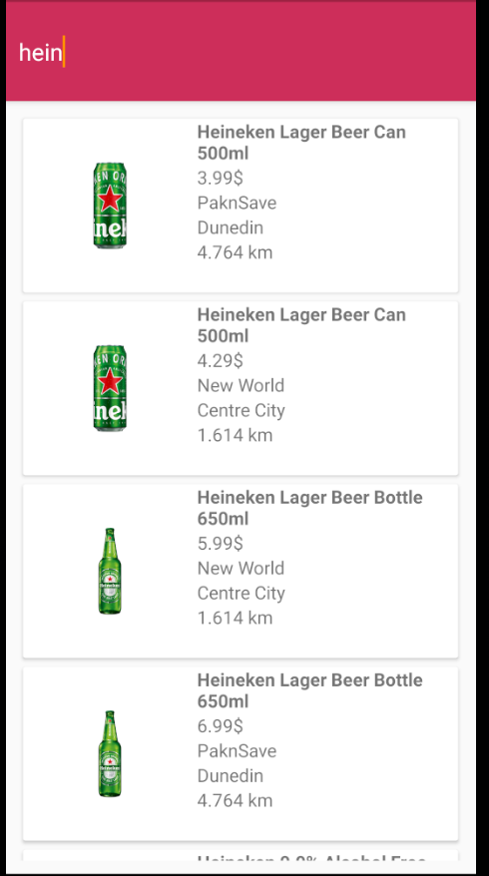Then you can tap the results to open the corresponding webpage for the result to look at the product in further detail or to buy via online shopping directly from the resellers webpage.

